

VM7000 Paperless recorder

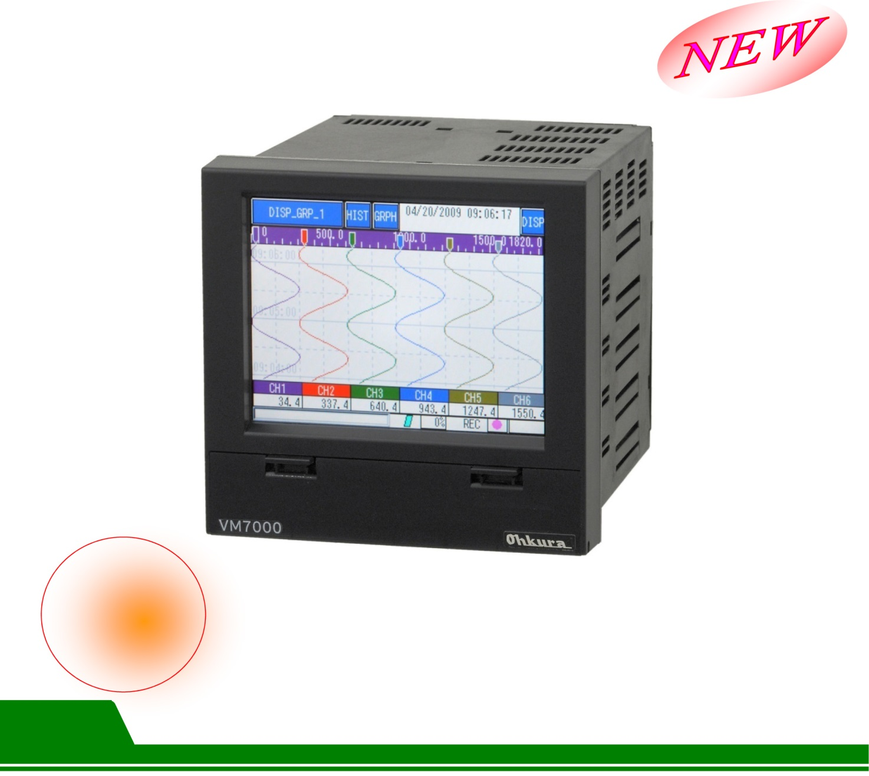

**Product Features**

Touch screen Chinese operation interface

High capacity with an embedded memory of 100MB

|  |  |  |
| --- | --- | --- |
| ■ 5.7” touch screen panel  ■ Multiple input type  ■ Multiple channel point number selection 3, 6, 9, 12  ■ Supports Chinese, English and Japanese operation interfaces |  | ■ Chinese character channel naming  ■ Auxiliary storage interface SD/SDHC card (Max. 32GB)  ■ IP65 protection rating (Panel)  ■ The communication interface Ethernet as standard |

**VM7000 Paperless recorder**

■ Specification

|  |  |  |  |  |  |
| --- | --- | --- | --- | --- | --- |
| **Input** | **No of Channels** | 3,6,9,12 channels  * If 12-channel is selected DI/DO or Relay card will not be added. | **Recording function** | **Auxiliary memory** | SD/SDHC card (Max. 32GB) |
| **Measuring cycle** | 100ms | **Major memory capacity** | 100MB |
| **Recording cycle** | 1sec to 60mins (For the SD card, recording can be 100ms) | **Recording method** | It starts the cyclic recording by using the REC button on the keyboard. After recording starts, a new recording file will be produced at a fixed time period. |
| **Input type** | Thermocouple:  (K,E,J,T,WRe5-26,N,PL II,U,L,R,S,B,PR40-  20,Au-Fe)  Resistance bulb:  (Pt100,JPt100)  DC voltage:  (-10 to +10mV, 0 to 20mV, 0 to 50mV  --200 to +200mV, -1 to +1V,  -10 to +10V, ,0 to 5V)  DC current: (must be connected to an external 250Ωresistor)  (4-20mA) | **Data storage cycle** | Relates to the curve recording update cycle |
| **Data file** | ASCII format: Each sampling cycle is approx. 300 bytes  Binary format: Each sampling cycle is approx. 80 bytes  (Cannot be read using Excel)  * Above are all using 12-channel. |
| **Performance** | **Product accuracy** | ±(0.1%+1digit) of input range | **Alarm function** | **No of setting** | Each channel can set up 4 sets |
| **Output** | One point (transistor output) |
| **Communication Interface** | **Ethernet 10 BASA-T** | HTTP server, FTP server and MODBUS TCP/IP protocol |
| **Display** | **LCD** | 5.7 inch TFT(QVGA) | **General** | **Fixing method** | Disk panel type |
| **Display contents** | • Curve display (horizontal curve, vertical curve)  Can select cycle of 1 sec-60min  • Bar chart display (update cycle: 1 sec)  • Incident log display (alarm or message)  • Data display  • Historical curve display (SD card or main memory data) | **Material** | PC-ABS (case, bezel) |
| **Dimension** | <Panel mount>  150(W)x144(H)x181.8(D) mm |
| **Weight** | Approx. 1 kg (6-channel) |
| **Input source** | 100V to 240V AC, 50/60Hz |
| **Source power** | Approx. 47VA (at 200VAC) |
| **Purchase** | **Relay card DI/DO card** | Relay : 6 points (1a contacts)  DI/DO: 9/12 point for each (transistor input/ output) |
| **Communication** | RS-485 MODBUS protocol |
|  |  |

■ Model selection

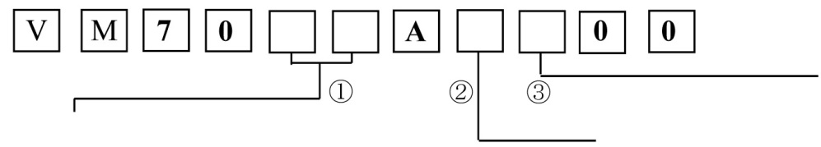

<Communication interface>

0: Ethernet (standard)

1: RS-485 (optional)

<No. of channels>

03: 3 Channels

06: 6 Channels

09: 9 Channels

12: 12 Channels

<Purchased functions>

0: Nil

1: DI/DO

2: Relay

* If the 12-channel is selected, DI/DO or Relay card cannot be added.

■ Dimension

